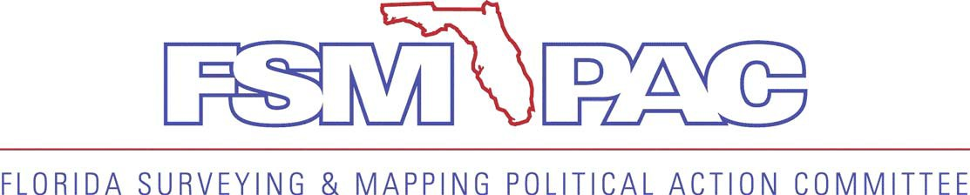
Corporate Contributor

BUSINESS INFORMATION – Required for Reporting Purposes Date:

Business Name (as registered with the State):
Business Address:
Business City: Business State: Business Zip:

Business Phone: Type of Business:

Contact Person: Email:

FSMPAC was formed to assist the legislative and political efforts of the Florida Surveying and Mapping Society. Without regard to political party affiliation, contributions and support are made to state and local candidates and political parties that share the views of Surveyors and Mappers on issues and initiatives important to the profession.

Contribution Levels:

_____ $250 Supporter ____ $500 Professional ____ $1000 Leader ____ $2500+ CEO

All contributors that donate $100 or more will receive a lapel pin to be worn proudly in support of their Surveying & Mapping profession.

Payment Information: Cash** Check Enclosed (Payable to FSMPAC) VISA MasterCard American Express

Card #: Exp. Date:

Billing Address: Zip Code:

Name on Card: Signature: CVV Code:

** Cash contributions are limited to $50 per election cycle by Florida Law

IF PAYING BY CHECK OR CREDIT CARD, MAIL FORM TO: FSMPAC, 311 East Park Ave,
Tallahassee, FL 32301 Attn: Debbie Wysocki
Contribute to the Political Action Committee that promotes your profession!
FLORIDA SURVEYING & MAPPING POLITICAL ACTION COMMITTEE

Contributions to FSMPAC are voluntary and are not a condition of membership in the Florida Surveying and Mapping Society. Contributions are not deductible for federal income tax purposes.

